Bachelorette Party Dare Lists
When you are putting together your own lists of dares, you can choose a theme or you can mix and match dares from different themes to create your own custom list. We are including both kinds of dare lists in our examples to give you some idea of how each dare list might look.

Give it a Shot
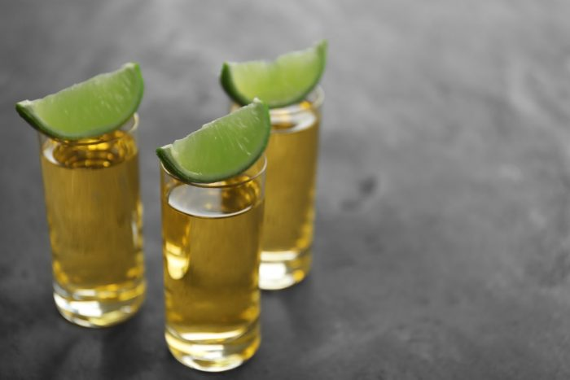
At a bachelorette party, you can anticipate taking a shot or two. After all, consuming copious amounts of alcohol is a tried-and-true part of the bachelorette party experience. However, this dare challenges you to step out of your comfort zone and avoid the same-old, same-old tequila or vodka shots. Simple enough to play, the goal is to finish one of each of these nine dessert-flavored liqueur shots by the end of the night:
- Banana Fairy- 1/3 each green banana syrup, Irish cream, and absinthe
- Chocolate Cake- ½ vanilla vodka, ¼ chocolate liqueur, ¼ hazelnut liqueur
- Cherry Cordial- 2/3 chocolate liqueur, 1/3 dark cherry rum
- Cloud- ½ vodka, ½ peach liqueur, a few drops of milk
- Deep Throat- ¾ vodka, ¼ coffee liqueur, top with whipped cream
- Monkey Brain- ½ vodka, ½ Irish cream, a few drops of grenadine
- Orgasm- 1/3 each Irish Cream, amaretto liqueur, and coffee liqueur
- Russian Black- 2/3 vodka, 1/3 coffee liqueur, ice
- White Russian- 4/6 vodka, 1/6 coffee liqueur, 1/6 milk or cream

Guy Collector
In this challenge, the dare stays the same, but you have to repeat it several times. The dare? Take a selfie with a guy that fits into one of the following categories. The real challenge is finding all of the guys and convincing them to take selfies with you.
- Bald Man
- Man with a great smile
- Man with his shirt off (not a stripper)
- Man with hair longer than his shoulders
- Ridiculously good looking man (obviously subjective, we suggest the bride be the judge of who found the best-looking guy of the night)
- Hipster
- Man wearing a hat
- Man with full sleeves (tattoos)
- Emo Man
- Man with a Great Beard
- Police Officer (in uniform)
- Firefighter (bonus points if the firefighter is in full uniform)
- Guy who looks like the groom (bonus points for whoever finds the guy that the bride thinks looks most like the groom)
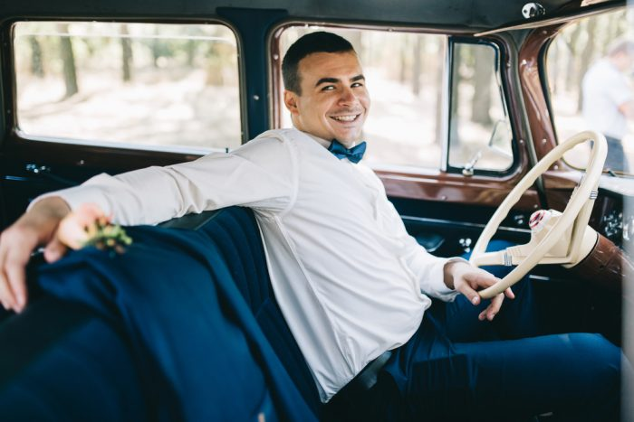

Mildly Embarrassing Dare List
One of the fun things about dare challenges is that you get to embarrass your friends. We put together this list of mildly embarrassing dares for groups of bachelorettes that might be a little shy.
- Sing It- Sing your order to the server at a restaurant. You must sing every time you talk to the server
- Sex it Up- Order a round of sexually named drinks for the group. There are a ton of drinks with sexy-sounding names. Order a round for your friends. Some suggestions: orgasm, buttery nipple, bend over Shirley, blue balls, red-headed slut, or sex on the beach
- Paparazzi- Approach a stranger in the bar. Act like they are someone famous and you are paparazzi or their biggest fan
- Top Gun- Sing “You’ve Lost that Loving Feeling” to a random guy at a bar
- Hey Bartender- Convince a bartender to let you behind the bar to make a drink
- Movie Madness- For a set period of time, speak only in movie quotes

Moderately Embarrassing Dare List
If your group full of people who do not embarrass easily? If so, feel free to kick the party up a notch and choose one of these moderately embarrassing list of dares that require you to interact with some people

Bar Games
All of the items on this list of dares must be completed in a bar. However, fair warning, some of them are sufficiently embarrassing that you might either be asked to leave that bar or choose to leave it and hit one or more other establishments to finish your list.
- Dance on the Bar- get up and dance on the bar or the table
- Line it Up- Do a line dance. Even better if you are not at a place that traditionally has line dances (this is best done as a group dare)
- A Toast to the Bride- Get a stranger to make up a toast to the bride and give it to her
- Do the hokey-pokey- You can ask the DJ to play the song, but this dare is even better when you dance the hokey pokey to any other song
- Statue- Freeze in the shape of a famous statue for a set period of time
- Alterna-loos- Use the men’s room when you go to the restroom. (Note- you are going to want to be aware of your local laws before doing this dare. In most places, it is just something that will give you a laugh. In some places, it might actually be illegal. Not worth risking a ticket or even an arrest for the dare)
- Bar-Made- Make yourself accessories from the bars you attend. Whatever creative combination of coasters, straws, cocktail napkins etc. you can come up with is fine. You have to make an accessory at each bar and you have to wear them the rest of the night
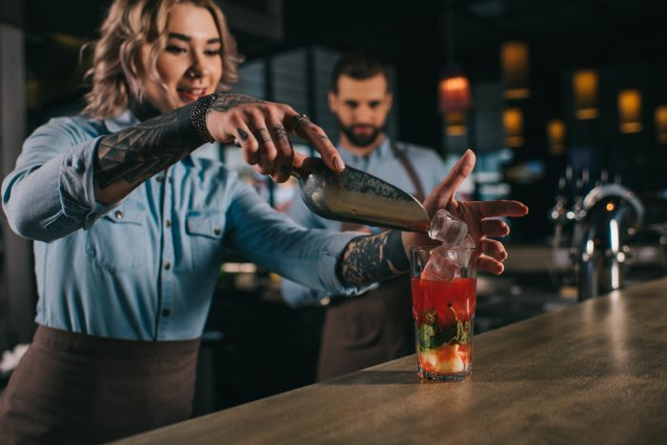

A Little Bit of Mischief
These dares get a little on the naughty side, but they are still relatively tame. They require a bit of flirting, a bit of fun, and probably a drink or two before you feel brave enough to try them.
- Blow a kiss- Blow a kiss to a random guy while you are out and about. We like the idea of deciding ahead of time what criteria you will use to choose the guy. Like, blow a kiss to the first guy you see with a visible tattoo. This one can even be done as a group dare. Just be prepared for it to be a conversation starter.
- Get the digits- another group dare, this one challenges all of your party goers to get as many phone numbers from guys as they can in a set amount of time. You can make it last all night long, but, in our opinion, that actually detracts from the fun. Instead, make it a five or ten-minute challenge!
- Sex Me Up- Get a guy to order you (and pay for) a sexy cocktail. Nervous about asking? Then we suggest asking a guy to get you an orgasm. Very few of them will say no, and the drink is pretty dang tasty.
- Ask a married couple for their best marriage advice. Bonus points if you can get them to give you sex advice. Collect the tips for the bride.
- Traditions- Go through the bar collecting things from strangers. What are you looking for? Something old, something new, something borrowed, something blue. Take pictures of the strangers you get them from, so you can return them if you need to.
- Bachelorette- Find another group celebrating a bachelorette party. Take a selfie with the bachelorette.

Very Daring List
We reserve the dares on this list for the most adventurous groups of gals. Because these lists are daring, they may take a full bachelorette party weekend to complete.

Bucket List
You know those daring things you say you want to do, but might never try? Well, how about if we dare you to do them? Just keep in mind that, in order to do them safely, you probably have to plan ahead for the dares on this list. You may also need to be at a certain level of physical conditioning and skill to complete them.
- Sky dive
- Swim with sharks
- Cliff dive
- Zip line
- Ride an extreme roller coaster
- Alpine roller coaster
- Night skiing
- Rock climb
- Catch a wave
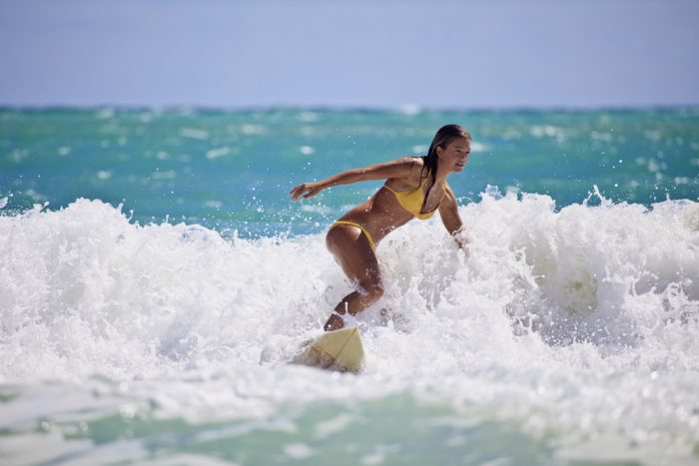

The Dirty Dozen
For this list, we are going to range from moderately naughty to what we think of as pretty outrageous.
- Strippers- Hit a gentleman’s club. Get a sexy photo with a stripper.
- Sign Me Up- Get a man’s signature somewhere on your torso that is normally covered by clothing
- Butt of Course- Twerk on a stranger
- Remove a stranger’s belt. Bonus points if you do it using only your mouth.
- Kiss the groom. Kiss the first man you meet that has the same name as the groom.
- Hitchhiker- Get a biker to give you a ride
- Strip down to your skivvies.
- Love is Blind. This one requires finding a guy at the bar who is willing to play along, but, once they know the rules of the game, it is usually not difficult to find someone to play. Pick out a cute guy. Convince him to let you blindfold him. Have one of the bachelorette party guests give him a kiss. See if he can guess who it was once the blindfold comes off!
- Safety Skills. Put a condom on a beer bottle using only your mouth. Bonus points if you get the condom from a guy at the bar.
- Share Your Sweets- This one is a group challenge. Every member of the party gets a candy necklace. The first one to get a different guy to eat off each piece of the necklace wins!
- Grab the Goodies- Another group or challenge game- each person must pinch or grab as many butts as she can within a set amount of time. One caveat- we are big on consent at Your Bach Party, so make sure and ask permission first.
- Stranger Things. Take off your bra without taking off any of the rest of your clothes. Give it to a stranger.

